**Exercise 1,**

Created a new maven project using IntelliJ IDEA.

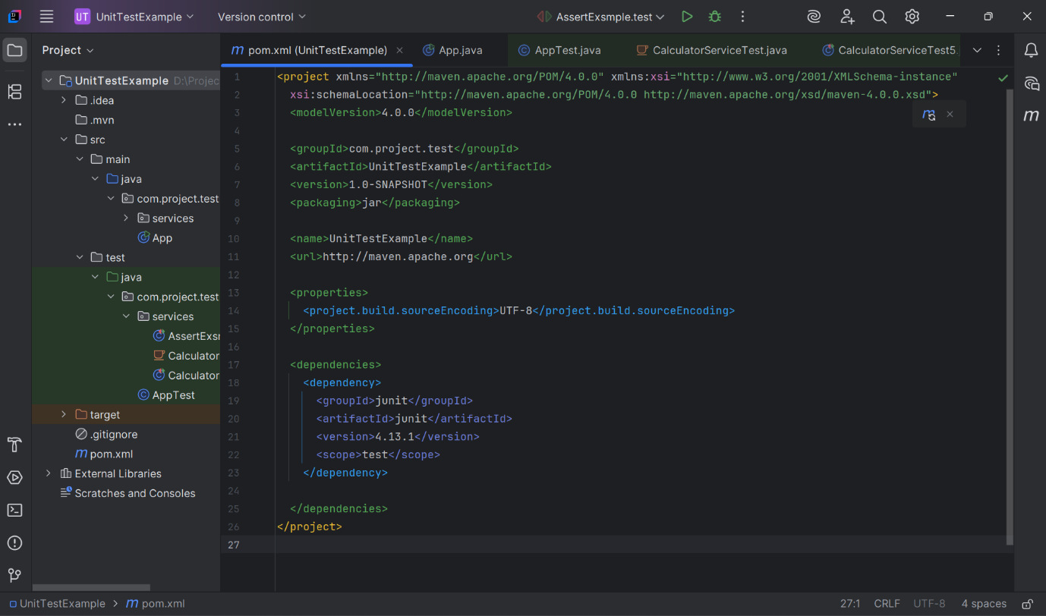Added JUnit4 to pom.xml

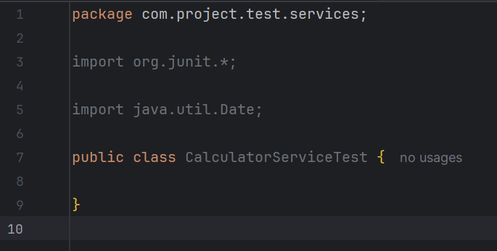Created a test class in my project.

**Exercise 3,**

Assertions in JUnit,

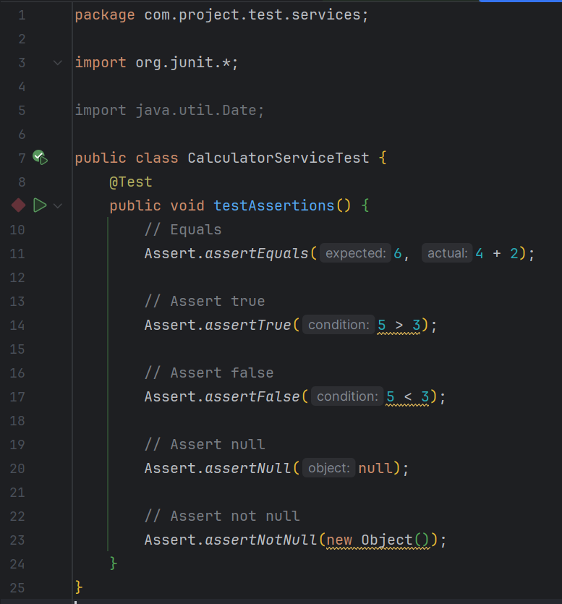

Output,

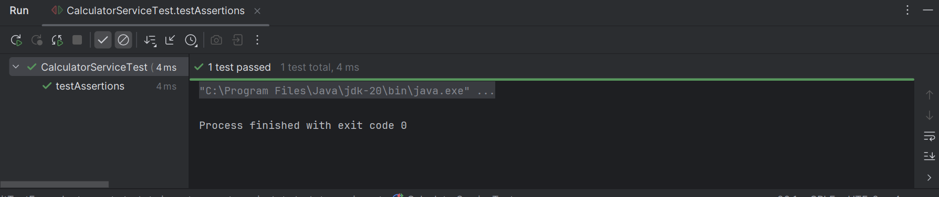

**Exercise 4: Arrange-Act-Assert (AAA) Pattern, Test Fixtures, Setup and teardown Methods in JUnit**

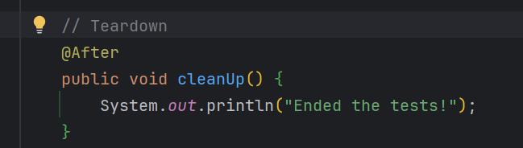

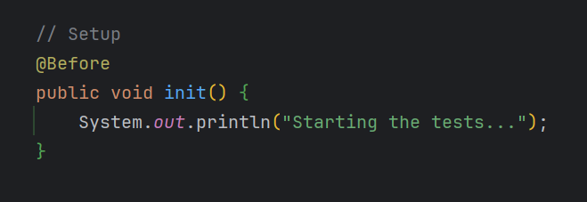Output,

